GRADUATION PROJECT | TECHNICAL DOCUMENTATION
Olist-Advanced-PowerBI-Pipeline-HW
End-to-end Power BI solution: data sourcing, cleaning, snow data model, DAX measures, interactive dashboard and business insights
Program Data Analysis Diploma
Institution Smart Investment Solution (SIS)
Author Hassan Wahba
Role Senior Electrical & Automation Engineer
Dataset Brazilian E-Commerce Public Dataset by Olist (Kaggle)
Tools Power BI Desktop · Power Query (M) · DAX
Date November 2026

GitHub: github.com/enghassanwahba · LinkedIn: linkedin.com/in/hassan-wahba-a0777013a

Document Contents
1. Executive Summary
2. Project Overview
3. Data Source and SIS Compliance
4. Dataset Description (files, rows, columns, dictionary)
5. Data Cleaning and Transformation (Power Query)
6. Data Model: Snowflake Schema and Calendar Table
7. DAX Measures
8. Dashboard Design and Visual Guide
9. Key Insights and Business Recommendations
10. Validation and Quality Assurance
11. Limitations and Future Work
12. Tools, Skills and Deliverables
Appendix A. DimDate Calculated Table (DAX)
Appendix B. Glossary

This document accompanies the project README on GitHub and the Power BI report file. The README is the short, public-facing summary; this document explains every stage of the work in full detail.

1. Executive Summary
This project builds a complete business-intelligence solution on the Brazilian E-Commerce Public Dataset by Olist, downloaded from Kaggle. Olist is a Brazilian marketplace that connects small businesses to large online sales channels. The dataset contains real, anonymized commercial data covering orders placed between 2016 and 2018, together with customers, sellers, products, payments and customer reviews.
The raw files were cleaned in Power Query, organized into a snow-schema data model, analyzed with DAX measures, and presented in a three-page interactive Power BI dashboard (Revenue, Customer and Reviews) that answers how the business is growing, which products and payment methods drive revenue, and how satisfied customers are.

Headline results
Metric | Value | Metric | Value
Total revenue | 16.01M BRL | Average rating | 4.09 / 5
Delivered orders | 96.48K | Star review Rting(5) | 57.77%
Unique customers | 96.10K | Negative review Rating(1,2) | 14.69%
Items sold | 112.65K | Credit-card share of revenue | ~78%

Key findings
- Revenue grew about 20% from 7.25M (2017) to 8.70M (2018), and delivered orders grew about 22% from 43.4K to 52.8K.
- The average order value fell from 222 in year (2016) to 167 in year (2017) and 165 in year (2018), so growth came from more orders, not bigger baskets.
- Credit card brings about 78% of revenue (12.54M), followed by boleto (2.87M).
- health_beauty is the top revenue category (1.45M), followed by watches_gifts (1.31M) and bed_bath_table (1.27M).
- Customer satisfaction is high overall, but negative-review rates are concentrated in a few categories such as office_furniture and audio.

2. Project Overview

2.1 Business context
E-commerce marketplaces generate large amounts of transactional data, but value comes only when it is cleaned, modeled and turned into decisions. This project simulates the work of a BI analyst who receives raw operational files from a marketplace and must deliver a reliable dashboard and a set of recommendations to management.

2.2 Objectives and business questions
- How have revenue and orders evolved from 2016 to 2018?
- Which payment methods generate the most revenue?
- How is the average order value changing over time?
- Which product categories drive the most revenue?
- How satisfied are customers, and which categories receive the best and the worst reviews?

2.3 Project workflow
# | Stage | What was done
1 | Source | Downloaded the Olist dataset from Kaggle and verified it meets the project requirements
2 | Load | Imported the CSV files into Power BI Desktop
3 | Clean | Cleaned and typed every table in Power Query, removing duplicates only on true keys
4 | Model | Built a snow schema with relationships and a DAX calendar table
5 | Measure | Wrote DAX measures for revenue, orders, customers and review KPIs
6 | Visualize | Designed a three-page interactive dashboard with slicers, synchronized filters and navigation
7 | Validate | Reconciled dashboard totals against the source files and between visuals
8 | Analyze | Extracted insights and business recommendations

2.4 Deliverables
- Power BI report file (.pbix) with the full model, measures and three report pages
- PDF export of the dashboard
- GitHub repository with README, dashboard screenshots and the data model diagram
- This technical documentation
- Presentation of the Project

3. Data Source and SIS Compliance

3.1 Source of the data
The data was obtained from Kaggle, one of the world's largest open-data platforms. The dataset is titled Brazilian E-Commerce Public Dataset by Olist and was published by Olist (Kaggle user *olistbr*).
Dataset name | Brazilian E-Commerce Public Dataset by Olist
Publisher | Olist, a Brazilian marketplace integrator
Platform | Kaggle
Link | https://www.kaggle.com/datasets/olistbr/brazilian-ecommerce
Content | About 100K orders placed between 2016 and 2018 across multiple Brazilian marketplaces, with customers, sellers, products, payments, reviews and geolocation
Format | 9 CSV files
Kaggle usability score | 10.0 (the maximum score)
License | CC BY-NC-SA 4.0 (attribution, non-commercial, share-alike). Used here for non-commercial educational purposes, with credit to Olist
Anonymization | Customer and seller identities are anonymized by the publisher

3.2 Compliance with the project requirements
The project guidelines require the dataset to come from a trusted platform, to be widely used, and to be large enough for real analysis. The dataset satisfies the following conditions:
Requirement | Condition | Evidence for the Olist dataset | Status
Source platform | Public, trusted platform | Published on Kaggle by the company that generated the data | Met
Popularity | More than 1,000 downloads | Kaggle lists about 687,000 downloads (and more than 2.6 million views) | Met
Data volume | More than 100,000 rows | The order-items table alone has 112,650 rows; payments has 103,886 rows; and the full dataset contains 1,550,922 rows across 9 files | Met
Relational structure | Supports multi-table analysis | 9 related tables linked by order, customer, product and seller keys, allowing a real data model | Met

4. Dataset Description
The dataset consists of 9 CSV files. The table below lists every file with its number of rows and columns as published in the source files, before any cleaning. Together, the files hold 1,550,922 rows.

4.1 Files, rows and columns
File | Rows | Columns | Description (grain) | In model
olist_customers_dataset | 99,441 | 5 | One row per customer ID (a new ID is created for each order) | Yes
olist_geolocation_dataset | 1,000,163 | 5 | Brazilian zip-code prefixes with latitude and longitude | No
olist_order_items_dataset | 112,650 | 7 | One row per item inside an order | Yes
olist_order_payments_dataset | 103,886 | 5 | One row per payment part of an order | Yes
olist_order_reviews_dataset | 99,224 | 7 | One row per customer review | Yes
olist_orders_dataset | 99,441 | 8 | One row per order; the core table with status and dates | Yes
olist_products_dataset | 32,951 | 9 | One row per product, with category and physical attributes | Yes
olist_sellers_dataset | 3,095 | 4 | One row per seller, with location | Yes
product_category_name_translation | 71 | 2 | Portuguese to English category names | Yes
Total | 1,550,922 | 52 | 9 files; 8 loaded into the model

The geolocation file (about 1 million rows) is the largest file but was intentionally not loaded into the model, because the dashboard does not include a map visual. It is listed as a future-work opportunity.

4.2 Column dictionary

customers (5 columns, 99,441 rows)
Column | Type | Meaning
customer_id | Text | Key linking the customer to an order. A new value is generated for every order
customer_unique_id | Text | Permanent identifier of the real customer. Used to count unique customers
customer_zip_code_prefix | Whole number | First five digits of the customer's zip code
customer_city | Text | Customer city
customer_state | Text | Customer state (two-letter code)

orders (8 columns, 99,441 rows)
Column | Type | Meaning
order_id | Text | Unique order identifier (primary key)
customer_id | Text | Links the order to the customers table
order_status | Text | Order status: delivered, shipped, canceled, unavailable, invoiced, processing, created or approved
order_purchase_timestamp | Date | Date and time the customer placed the order. Converted to date only for the calendar relationship
order_approved_at | Date/time | Payment approval time
order_delivered_carrier_date | Date/time | Time the order was handed to the logistics partner
order_delivered_customer_date | Date/time | Actual delivery time to the customer
order_estimated_delivery_date | Date/time | Delivery date promised to the customer

order_items (7 columns, 112,650 rows)
Column | Type | Meaning
order_id | Text | Links the item to its order
order_item_id | Whole number | Position of the item inside the order (1, 2, 3, …)
product_id | Text | Links the item to the products table
seller_id | Text | Links the item to the sellers table
shipping_limit_date | Date/time | Deadline for the seller to hand the item to the carrier
price | Decimal | Item price
freight_value | Decimal | Freight cost allocated to the item

order_payments (5 columns, 103,886 rows)
Column | Type | Meaning
order_id | Text | Links the payment to its order
payment_sequential | Whole number | Sequence number of the payment part when an order is paid by several methods
payment_type | Text | Payment method: credit_card, boleto, voucher or debit_card
payment_installments | Whole number | Number of installments chosen by the customer
payment_value | Decimal | Amount paid in this payment part(Item price+Freight cost)

order_reviews (7 columns, 99,224 rows)
Column | Type | Meaning
review_id | Text | Review identifier
order_id | Text | Links the review to its order
review_score | Whole number | Satisfaction score from 1 (worst) to 5 (best)
review_comment_title | Text | Optional comment title (removed in cleaning)
review_comment_message | Text | Optional comment text (removed in cleaning)
review_creation_date | Date/time | Date the satisfaction survey was sent
review_answer_timestamp | Date/time | Date and time the customer answered the survey

products (9 columns, 32,951 rows)
Column | Type | Meaning
product_id | Text | Unique product identifier (primary key)
product_category_name | Text | Category name in Portuguese
product_name_lenght | Whole number | Number of characters in the product name (spelling as in the source)
product_description_lenght | Whole number | Number of characters in the description (spelling as in the source)
product_photos_qty | Whole number | Number of product photos
product_weight_g | Whole number | Weight in grams
product_length_cm | Whole number | Length in centimeters
product_height_cm | Whole number | Height in centimeters
product_width_cm | Whole number | Width in centimeters

sellers (4 columns, 3,095 rows)
Column | Type | Meaning
seller_id | Text | Unique seller identifier (primary key)
seller_zip_code_prefix | Whole number | First five digits of the seller's zip code
seller_city | Text | Seller city
seller_state | Text | Seller state (two-letter code)

product_category_name_translation (2 columns, 71 rows)
Column | Type | Meaning
Column1 | Text | Category name in Portuguese (headers were not promoted, so Power Query names the columns Column1 and Column2)
Column2 | Text | Category name in English

4.3 Data characteristics worth knowing
- Grain differs by table. An order can have several items, several payment parts and, in rare cases, more than one review. This is why duplicate removal must use the correct key in each table.
- Customer IDs are per order. customer_id changes with every order, while customer_unique_id identifies the real person. Unique customers must therefore be counted on customer_unique_id.
- Not every order is delivered. Orders have eight possible statuses, so revenue and order measures must define which statuses they include.
- Currency. Monetary values are in Brazilian reais (BRL).
- Missing values. Product category, photo count and text-length fields contain empty values, and delivery dates are empty for orders that were not delivered.
- Time span. Orders run from late 2016 to 2018, and 2016 has very few orders, so comparisons are most reliable between 2017 and 2018.

5. Data Cleaning and Transformation (Power Query)
All tables were loaded from the Olist CSV files and cleaned in Power Query using the M language. The guiding rule of the whole pipeline is: remove duplicates only on each table's true key, never on descriptive columns such as zip code, category or score. This protects real transactions from being deleted and keeps revenue, orders and customer counts complete.

5.1 Steps common to every table
Step | What it does
Source | Loads the CSV file (comma-delimited) with the correct number of columns and encoding: Windows-1252 for most tables, UTF-8 for order_reviews and sellers, which contain special characters
Promoted Headers | Turns the first row of the file into column names
Changed Type | Assigns the correct data type to every column (text for IDs, whole number for counts, decimal for money, date/time for timestamps) so relationships, sums and date logic work correctly

5.2 customers (5 columns)
Step | What it does and why
Changed Type | customer_id and customer_unique_id as text, zip code as whole number, city and state as text
Removed Duplicates on customer_id | Guarantees one row per customer_id, the key that links customers to orders. This makes the relationship a clean one-to-many
Filtered Rows | Removes rows where customer_id is empty or null, since a customer without a key cannot be linked to any order
customer_unique_id was intentionally left untouched so the Total_Customers measure can count real, unique customers.

5.3 orders (8 columns)
Step | What it does and why
Changed Type | IDs and order_status as text; the five date columns as date/time
Removed Duplicates on order_id | Guarantees one row per order, the key that links orders to items, payments and reviews
Filtered Rows | Removes rows with an empty order_id
Changed Type (purchase date) | Converts order_purchase_timestamp from date/time to date only, so it matches the date column of the DimDate calendar table and the Year slicer and trend charts work per day
All order statuses are kept in this table. The delivered-only logic is applied in the Total_Orders DAX measure, so no payments are left without a matching order.

5.4 order_items (7 columns)
Step | What it does and why
Changed Type | IDs as text, order_item_id as whole number, shipping limit date as date/time, price and freight_value as decimals
Removed Duplicates on order_id + order_item_id | The real key of this table is the combination of the order and the item's position inside it. An order with three products has three rows, and all of them are kept
Filtered Rows | Removes rows with an empty order_id

5.5 order_payments (5 columns)
Step | What it does and why
Changed Type | order_id and payment_type as text, payment_sequential and payment_installments as whole numbers, payment_value as decimal
Removed Duplicates on order_id + payment_sequential | An order can be paid in several parts (for example card plus voucher), and payment_sequential numbers each part. Using both columns keeps every real payment, so total revenue is complete
Filtered Rows | Removes rows with an empty order_id

5.6 order_reviews (7 columns)
Step | What it does and why
Source (UTF-8, CSV quoting) | The review comments contain commas, line breaks and Portuguese characters, so the file is read as UTF-8 with CSV quote handling to keep rows intact
Changed Type | IDs as text, review_score as whole number, creation date and answer time as date/time
Sorted Rows (newest answer first) + Buffer | Sorts reviews by review_answer_timestamp descending and freezes that order in memory, so the next step reliably keeps the newest review
Removed Duplicates on order_id | Some orders have more than one review. Keeping only the latest review per order makes the relationship with orders one-to-one and avoids counting an order twice
Filtered Rows | Removes rows with an empty order_id
Removed Columns | Drops review_comment_title and review_comment_message. They are free text that the dashboard does not use, and removing them makes the model lighter

5.7 products (9 columns)
Step | What it does and why
Changed Type | IDs and category as text; name length, description length, photo count, weight and the three dimensions as whole numbers
Merged Queries (left outer join) | Joins product_category_name_translation on the Portuguese category name, so each product gets its English category. A left join keeps every product even when no translation exists
Renamed + Expanded Columns | Renames the joined table column to product_category_name_English and expands it to bring in the English name
Replaced Value: null to Others (English name) | Products without an English translation are grouped under Others instead of showing a blank category in the charts
Replaced Value: null to 0 (product_photos_qty) | Missing photo counts become 0
Changed Type (product_photos_qty) | Re-applies whole-number type after the replacement
Replaced Value: empty to Others (product_category_name) | Products with an empty Portuguese category are also labeled Others
Replaced Value: null to 0 (product_description_lenght, product_name_lenght) | Missing description and name lengths become 0
Removed Duplicates on product_id | Guarantees one row per product, the key linking products to order items

5.8 sellers (4 columns)
Step | What it does and why
Changed Type | seller_id, city and state as text, zip code as whole number
Removed Duplicates on seller_id | Guarantees one row per seller, the key linking sellers to order items
Filtered Rows | Removes rows with an empty seller_id

5.9 Other tables
- product_category_name_translation: loaded as is; its headers were not promoted, so its two columns are named Column1 (Portuguese) and Column2 (English). It is merged into products and has no relationships of its own.
- DimDate: not imported; it is a calculated table created with DAX (see Section 6.4 and Appendix A).

5.10 Design principles of the pipeline
- Remove duplicates only on each table's true key, so no real transactions are lost.
- Keep all order statuses in Power Query and filter delivered orders in DAX, so revenue, orders and dates stay consistent.
- Replace missing values with clear labels (Others, 0) instead of leaving blanks in the visuals.
- Drop unused heavy columns such as free-text review comments to keep the model light.

6. Data Model: Snow Schema and Calendar Table

6.1 Why a snow schema
The model is a snow schema built in Power BI's Model view. Instead of connecting every dimension directly to the fact tables, some dimensions (customers and DimDate) connect through the `orders` table, which then feeds the fact tables. This normalized, multi-level structure keeps each piece of information in one place and avoids repeating customer and date details on every row.
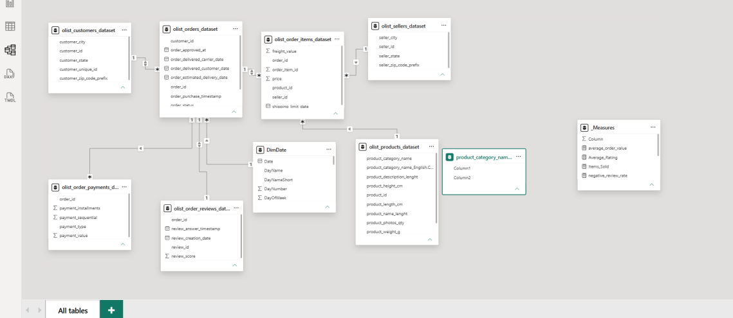
Figure 1. Snow schema: dimensions reach the fact tables through the central orders table.

6.2 Roles of the tables
Role | Tables
Fact tables | order_items, order_payments, order_reviews
Dimension tables | customers, products, sellers, DimDate
Central order table | orders, linking customers and dates to the fact tables
Measures table | _Measures, holds the DAX measures and has no relationships

6.3 Relationships
From (One) | To (Many) | Key | Cardinality | Filter direction
customers | orders | customer_id | One to many | Both
DimDate | orders | Date to purchase date | One to many | Single
orders | order_items | order_id | One to many | Both
orders | order_payments | order_id | One to many | Single
orders | order_reviews | order_id | One to one | Both
products | order_items | product_id | One to many | Single
sellers | order_items | seller_id | One to many | Single

The customers to orders and orders to order_items relationships filter in both directions, so category and customer slicers also filter reviews and revenue. The one-to-one relationship with reviews exists because the review table keeps only the latest review per order.

6.4 The DimDate calendar table
DimDate is a calculated table created with DAX inside the model. It is the date dimension that powers the Year slicer and every time-based chart.
Build step | What it does
Variables | Finds the earliest and latest year of the order purchase date in orders (2016 to 2018), and sets the fiscal year start month to April
CALENDAR | Generates one row per day, from January 1, 2016 to December 31, 2018, so the calendar has no gaps
ADDCOLUMNS | Adds descriptive columns (year, quarter, month, week, day and fiscal attributes) to every date

DimDate columns (28 in total)
Group | Columns | Meaning
Key | Date | One row per day; related to the purchase date in orders
Year | Year, Year Start, YearEnd | Calendar year and its first and last day
Month | MonthNumber, MonthName, MonthNameShort, MonthStart, MonthEnd, DaysInMonth | Month number (1–12), full and short name, first and last day, number of days
Year-month | YearMonthNumber, YearMonthName | Sortable key such as 201709 and a label such as 2017-Sep
Day | DayNumber, DayName, DayNameShort, DayOfWeek | Day of month, full and short weekday name, weekday number
Quarter | Quarter, QuarterName, YearQuarterNumber, YearQuarterName, QuarterStart, QuarterEnd | Quarter number, label such as Q3, year-quarter key and label, first and last day
Week | WeekNumber, WeekStart, WeekEnd | Week of the year and the first and last day of that week
Fiscal | FiscalYear, FiscalQuarter, FiscalMonth | Fiscal calendar with the year starting in April

Why a separate calendar table: it lets all time analysis run on one shared, gap-free date column, so year, quarter and month views stay consistent across every page.

7. DAX Measures
All measures live in a dedicated _Measures table. They are grouped into sales and customer measures, and review measures.

7.1 Measure summary
Measure | What it returns | Result (all data)
Total_Revenue | Sum of payment value | 16.01M BRL
Total_Orders | Distinct delivered orders | 96.48K
Total_Customers | Distinct unique customers | 96.10K
Items_Sold | Number of items sold | 112.65K
average_order_value | Revenue divided by orders | 222 (2016), 167 (2017), 165 (2018)
total_reviews | Number of reviews | About 99K
Average_Rating | Average review score (1–5) | 4.09
star_review_rate | Share of five-star reviews | 57.77%
negative_review_rate | Share of one- and two-star reviews | 14.69%

7.2 Sales and customer measures
-- Total money paid by customers
Total_Revenue = CALCULATE(
SUM(olist_order_payments_dataset[payment_value])
)

-- Distinct orders that were delivered
Total_Orders =
CALCULATE(
DISTINCTCOUNT(olist_orders_dataset[order_id]),
olist_orders_dataset[order_status] = "delivered"
)

-- Distinct customers (a customer may have several customer_id values)
Total_Customers = CALCULATE(
DISTINCTCOUNT(olist_customers_dataset[customer_unique_id])
)

-- Number of items sold
Items_Sold = CALCULATE(
COUNT(olist_order_items_dataset[product_id])
)

-- Average value of an order
average_order_value = [Total_Revenue] / [Total_Orders]
- Total_Revenue sums payment_value from the payments table. Because the payments table keeps every payment part, the total is complete.
- Total_Orders counts distinct order_id values in the orders table, restricted to the delivered status. Using DISTINCTCOUNT prevents an order from being counted once per item.
- Total_Customers counts distinct customer_unique_id values. A plain count would be wrong, because the same person can have several customer_id values.
- Items_Sold counts the rows of the order-items table, where each row is one item sold.
- average_order_value divides revenue by delivered orders, giving the average value generated per order.

7.3 Review measures
-- Number of reviews
total_reviews = CALCULATE(
COUNT(olist_order_reviews_dataset[review_id])
)

-- Average rating (1 to 5)
Average_Rating = CALCULATE(
AVERAGE(olist_order_reviews_dataset[review_score])
)

-- Share of 5-star reviews
star_review_rate = CALCULATE(
COUNT(olist_order_reviews_dataset[review_score]),
olist_order_reviews_dataset[review_score] = 5
) / [total_reviews]

-- Share of negative reviews (1 or 2 stars)
negative_review_rate = CALCULATE(
COUNT(olist_order_reviews_dataset[review_score]),
olist_order_reviews_dataset[review_score] <= 2
) / [total_reviews]
- total_reviews counts reviews. Because the review table keeps one review per order, this is also the number of reviewed orders.
- Average_Rating averages the 1-to-5 score.
- star_review_rate counts five-star reviews and divides them by all reviews.
- negative_review_rate counts reviews with a score of 1 or 2 and divides them by all reviews.
All measures respond to the slicers on the page. Selecting a year, category or payment type changes every measure, because the filter travels through the relationships described in Section 6.

8. Dashboard Design and Visual Guide
All three pages share the same design: a dark background, green and orange accent colors, rounded borders around every visual, the Olist logo on the top left, slicers on the top right and four KPI cards on the left. Every visual is driven by the DAX measures and the data model described above.

8.1 Navigation and interaction (all pages)
Element | How it was built
Page buttons (Revenue, customer, reviews) | Speech-bubble shaped buttons with a Page navigation action. The button of the current page is highlighted in light green
Filter button (funnel icon) | An icon button next to the slicers that gives a quick way to reset the filters
Olist logo | An image placed in a white rounded banner on the top left
Slicers | Dropdown slicers set to *All* by default. They filter every visual on the page through the model relationships. The Year slicer is synchronized between the Revenue and Customer pages, and the category_name slicer between the Customer and Reviews pages, so a selection carries over when you switch pages. The payment_type and review_score slicers exist on one page only

8.2 Page 1: Revenue
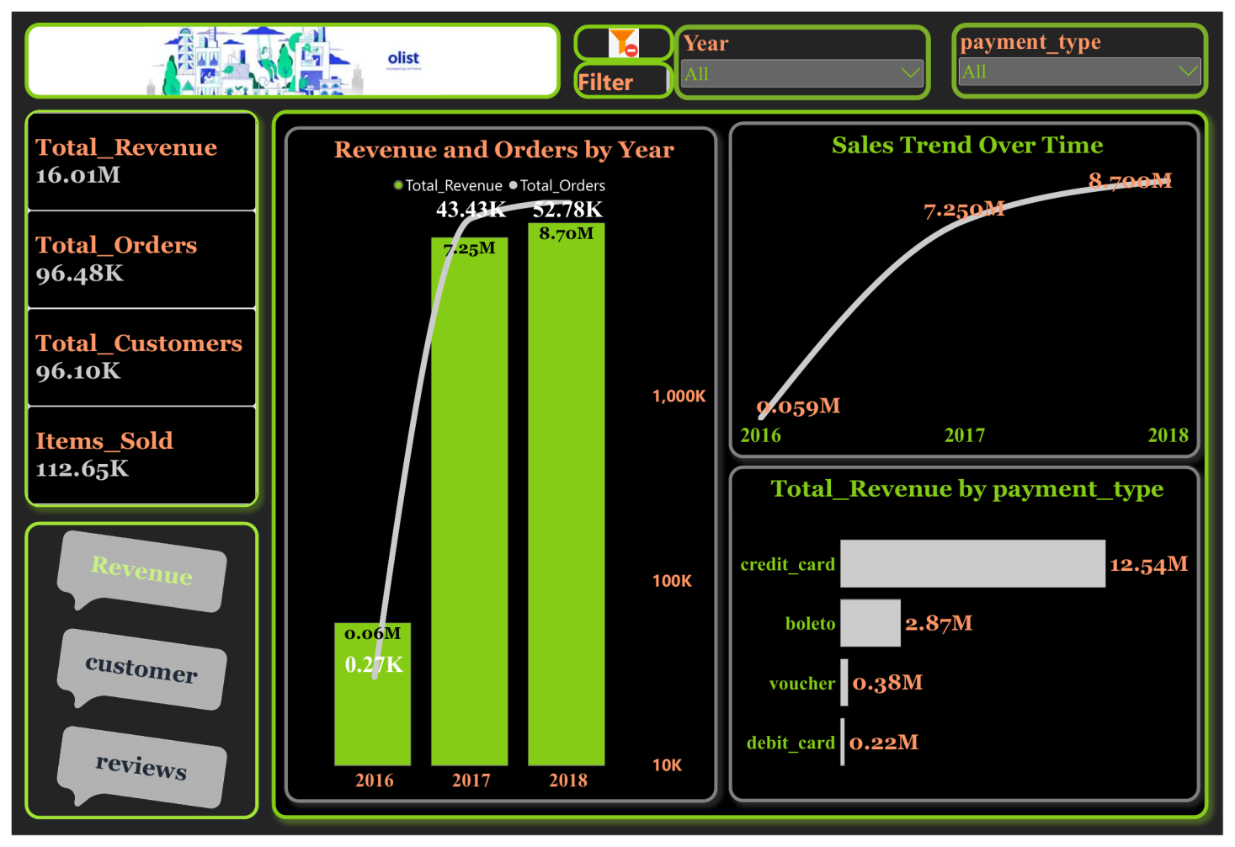
Figure 2. Revenue page.
Visual | Type | Fields | Notes
Year slicer | Dropdown slicer | DimDate[Year] | Filters revenue, orders and all charts by year
payment_type slicer | Dropdown slicer | order_payments[payment_type] | Filters by credit card, boleto, voucher and debit card
KPI cards (4) | Card | Total_Revenue, Total_Orders, Total_Customers, Items_Sold | Label in orange, value in white
Revenue and Orders by Year | Combo chart (columns and line) | X-axis: DimDate[Year]. Columns: Total_Revenue. Line: Total_Orders | Secondary axis uses a logarithmic scale so 2016, which has very few orders, stays visible next to 2017 and 2018
Sales Trend Over Time | Smoothed line chart | X-axis: DimDate[Year]. Y-axis: Total_Revenue | Labels show revenue in millions with three decimals
Total_Revenue by payment_type | Horizontal bar chart | Y-axis: payment_type. X-axis: Total_Revenue | Shows how much revenue each payment method brings

What the page shows: revenue and orders both grew strongly from 2017 to 2018, and credit card is by far the dominant payment method (12.54M of 16.01M), followed by boleto (2.87M).

8.3 Page 2: Customer
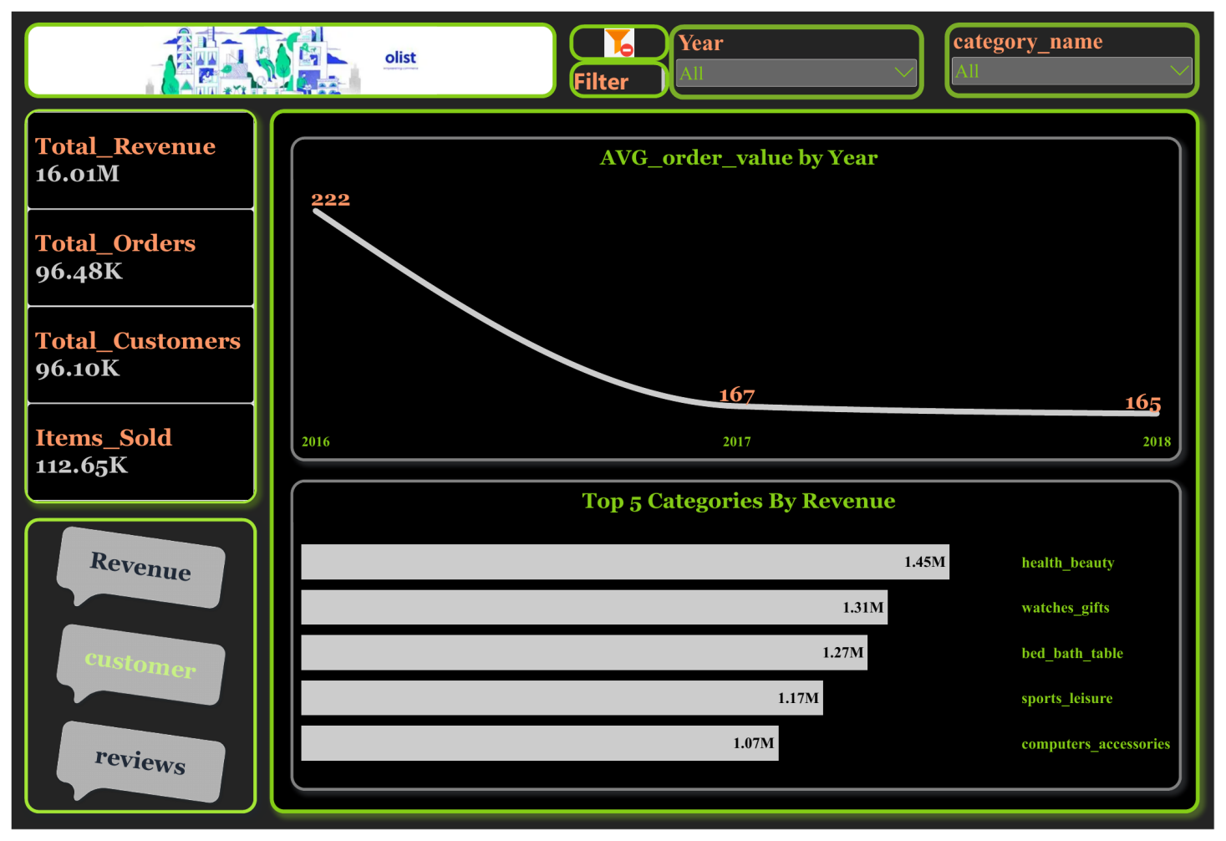
Figure 3. Customer page.
Visual | Type | Fields | Notes
Year slicer | Dropdown slicer | DimDate[Year] | Synchronized with the Revenue page
category_name slicer | Dropdown slicer | English product category from products | Synchronized with the Reviews page
KPI cards (4) | Card | Total_Revenue, Total_Orders, Total_Customers, Items_Sold | Same cards as the Revenue page
AVG_order_value by Year | Smoothed line chart | X-axis: DimDate[Year]. Y-axis: average_order_value | Shows how the value of an average order changes
Top 5 Categories By Revenue | Horizontal bar chart | Y-axis: English product category. X-axis: Total_Revenue | A Top N filter keeps the 5 categories with the highest revenue

What the page shows: the average order value dropped from 222 to 165 while the top five categories (health_beauty, watches_gifts, bed_bath_table, sports_leisure and computers_accessories) each bring more than 1M in revenue.

8.4 Page 3: Reviews
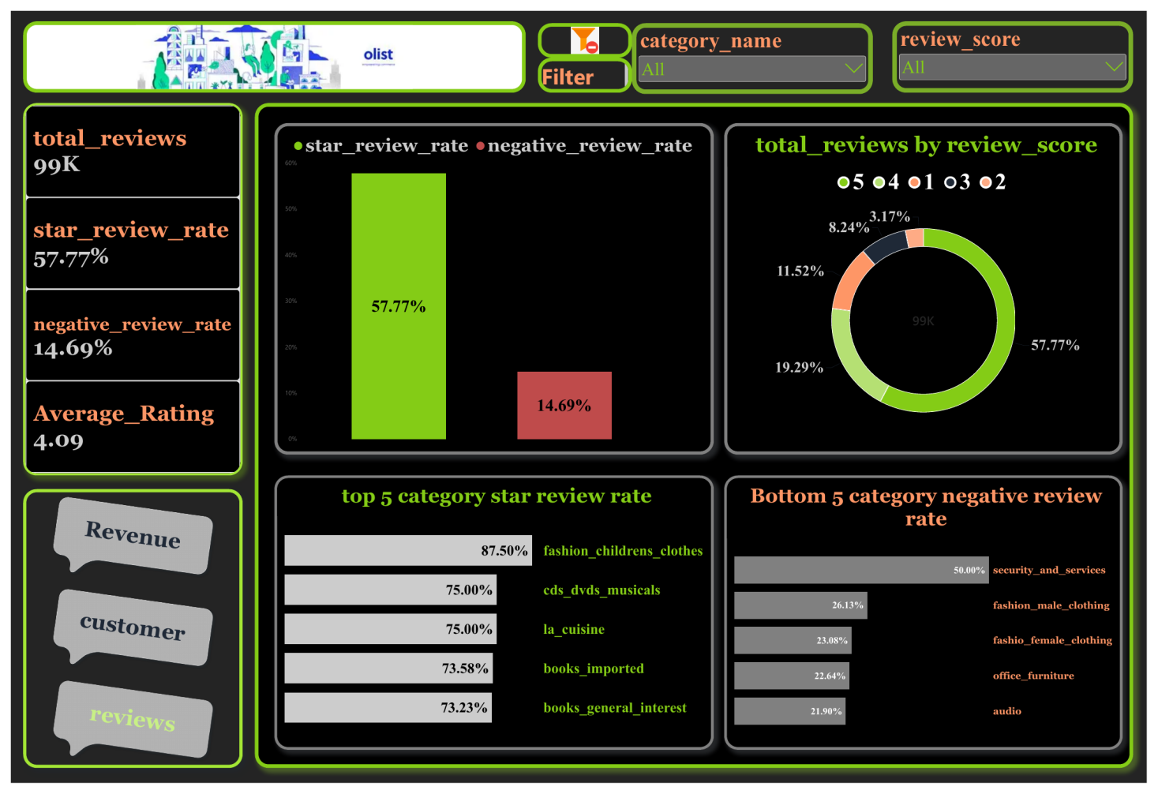
Figure 4. Reviews page.
Visual | Type | Fields | Notes
category_name slicer | Dropdown slicer | English product category from products | Synchronized with the Customer page
review_score slicer | Dropdown slicer | order_reviews[review_score] | Filters by 1 to 5 stars
KPI cards (4) | Card | total_reviews, star_review_rate, negative_review_rate, Average_Rating | Rates are formatted as percentages with two decimals
star_review_rate vs negative_review_rate | Column chart | Values: star_review_rate (green) and negative_review_rate (red) | Two measures side by side with a legend, for a quick view of the satisfaction balance
total_reviews by review_score | Donut chart | Legend: review_score. Values: total_reviews | Labels show each score's percentage, and the total (99K) is shown in the center
top 5 category star review rate | Horizontal bar chart | Y-axis and legend: English product category. X-axis: star_review_rate | A Top N filter keeps the 5 categories with the highest star-review rate
Bottom 5 category negative review rate | Horizontal bar chart | Y-axis and legend: English product category. X-axis: negative_review_rate | A Top N filter keeps the 5 categories with the highest negative-review rate, meaning the worst performers

What the page shows: 57.77% of reviews are five-star and 14.69% are negative. The worst categories by negative rate are security_and_services (50.00%), fashion_male_clothing (26.13%), fashio_female_clothing (23.08%), office_furniture (22.64%) and audio (21.90%).

9. Key Insights and Business Recommendations

9.1 Insights
Area | Finding
Revenue | Total revenue of 16.01M; grew from 7.25M (2017) to 8.70M (2018), about +20%
Orders | 96.48K delivered orders; up from 43.4K (2017) to 52.8K (2018), about +22%
Customers and items | 96.10K unique customers and 112.65K items sold. Customers are almost as many as orders, which suggests few repeat purchases
Payments | Credit card brings 12.54M (~78%), then boleto (2.87M), voucher (0.38M) and debit card (0.22M)
Order value | Average order value fell from 222 (2016) to 167 (2017) and 165 (2018)
Top categories | health_beauty (1.45M), watches_gifts (1.31M), bed_bath_table (1.27M), sports_leisure (1.17M), computers_accessories (1.07M)
Satisfaction | Average rating 4.09 / 5; 57.77% of reviews are five-star and 14.69% are negative
Weakest categories | Highest negative-review rates: security_and_services (50.00%), fashion_male_clothing (26.13%), fashio_female_clothing (23.08%), office_furniture (22.64%), audio (21.90%)
Strongest categories | Highest star-review rates: fashion_childrens_clothes (87.50%), cds_dvds_musicals (75.00%), la_cuisine (75.00%), books_imported (73.58%), books_general_interest (73.23%)

The top and bottom review-rate categories are mostly small categories with few reviews, so their rates should be read with caution.
fashio_female_clothing is spelled this way in the original Olist data.

9.2 Recommendations
- Reduce dependence on credit cards. About 78% of revenue comes from one payment channel. Promote boleto, debit and voucher offers and installment options, and review processing costs of the card channel.
- Lift the average order value. It fell from 222 to 165 while orders grew. Introduce bundles, free-shipping thresholds and cross-selling inside the top categories.
- Double down on the leading categories. health_beauty, watches_gifts and bed_bath_table are the largest revenue drivers and deserve marketing and seller-onboarding support.
- Investigate the worst-rated categories. office_furniture, audio and fashion show high negative rates. Review product quality, delivery delays and listing accuracy for these sellers.
- Use the best-rated categories as quality benchmarks when onboarding and evaluating sellers.
- Encourage repeat purchases. With customers nearly equal to orders, loyalty programs and post-purchase campaigns are an untapped growth lever.

10. Validation and Quality Assurance
Before the dashboard was finalized, totals were reconciled against the source files and between visuals. This section documents the checks and the issues found and fixed.

10.1 Reconciliation checks
Check | Calculation | Result | Status
Revenue by year equals total revenue | 0.059M + 7.25M + 8.70M | 16.01M | Pass
Revenue by payment type equals total revenue | 12.54M + 2.87M + 0.38M + 0.22M | 16.01M | Pass
Orders by year equal total orders | 0.27K + 43.43K + 52.78K | 96.48K | Pass
Items sold equals source row count | Order-items file has 112,650 rows | 112.65K | Pass
Unique customers match source | Distinct customer_unique_id in the customers file | 96.10K | Pass
Review score shares add to 100% | 57.77 + 19.29 + 11.52 + 8.24 + 3.17 | 99.99% | Pass
Negative rate equals scores 1 and 2 | 11.52% + 3.17% | 14.69% | Pass
Average order value is consistent | 7.25M / 43.43K and 8.70M / 52.78K | 167 and 165 | Pass

10.2 Issues identified and resolved
During validation, early totals were lower than the source files indicated. The cause was duplicate removal applied to non-key columns in several tables, which deleted real records. After correcting each table to deduplicate on its true key, the totals matched the sources.
Measure | Initial value | Final value | Cause of the difference
Total customers | 15K | 96.10K | Duplicates removed on the zip-code column
Delivered orders | 78K | 96.48K | Rows lost through duplicate removal on non-key columns in the customers and order-items tables
Items sold | 80K | 112.65K | Duplicates removed on order ID alone and repeated-value filters
Total revenue | 15.74M | 16.01M | Multi-part payments removed by deduplicating on order ID alone
Total reviews | 98K | 99K | Duplicates removed on the review ID

10.3 Model checks
- Relationship cardinality was checked against the data: the one-to-one link with reviews is valid only because one review per order is kept.
- Category slicers were tested and now produce different values per category on the Reviews and Customer pages, which required bi-directional filtering from orders to order items.
- The customers relationship was rebuilt on customer_id on both sides, replacing a link that used customer_unique_id.
- The calendar table was rebuilt from the order purchase date so its range matches the data.

11. Limitations and Future Work

11.1 Limitations
- Review rates for very small categories are based on few reviews, so the top and bottom rankings can be misleading.
- The data has no cost or profit fields, so the analysis covers revenue, not profitability.
- The dataset covers 2016–2018 only, and 2016 has very few orders, so year-over-year comparison is most reliable for 2017 versus 2018.
- Total revenue includes payments of all order statuses, while orders and customers use delivered orders and all customers respectively, so the average order value is an approximation based on those definitions.

11.2 Future work
- Delivery performance: actual versus estimated delivery time and its effect on review scores.
- Seller performance and geographic analysis of sales by state, using the geolocation file.
- Customer segmentation (RFM) and repeat-purchase behavior.
- A minimum-review threshold on category rankings to avoid small-sample effects.
- Review text analysis using the comment fields removed during cleaning.

12. Tools, Skills and Deliverables

12.1 Tools and technologies
Tool | Use in the project
Kaggle | Source of the dataset
Power BI Desktop | Data modeling, interactive visuals, navigation buttons, slicers and report design
Power Query (M) | Data cleaning and transformation of every table
DAX | KPI measures for revenue, orders, customers and reviews, plus the DimDate calculated table
GitHub | Hosting the README, screenshots, model diagram and report files

12.2 Skills demonstrated
- Data sourcing and requirement validation
- Data cleaning and transformation with Power Query
- Data modeling with a snow schema and a calendar dimension
- DAX measures and calculated tables
- Dashboard design, interactivity and storytelling
- KPI definition, reconciliation and data validation
- Business insight and recommendation writing

12.3 Repository and deliverables
Item | Description
README.md | Public summary of the project with screenshots, insights, model and measures
image | the snow schema diagram
.pbix report file | Full Power BI report with model, measures and three pages
PDF export | Static export of the three dashboard pages
This document | Full technical documentation of every stage
Power Point Presentation | Presentation Slides of the Whole Project

12.4 Acknowledgements and references
- Dataset: Brazilian E-Commerce Public Dataset by Olist, published on Kaggle: https://www.kaggle.com/datasets/olistbr/brazilian-ecommerce. Licensed under CC BY-NC-SA 4.0.
- Thanks to Olist for releasing the dataset.
- Project completed as the graduation project of the Data Analysis Diploma at Smart Investment Solution (SIS).
- Academic Advisor : Dr.Mohamed Sobhy

Author: Hassan Wahba ·
eng_hassanwahbawork@gmail.com
GitHub: github.com/enghassanwahba
LinkedIn: linkedin.com/in/hassan-wahba-a0777013a

Appendix A. DimDate Calculated Table (DAX)
The calendar table is created as a calculated table. The date range comes from the order purchase date, and the fiscal year is set to start in April.
DimDate =
VAR _minYear = YEAR(MIN(olist_orders_dataset[order_purchase_timestamp]))
VAR _maxYear = YEAR(MAX(olist_orders_dataset[order_purchase_timestamp]))
VAR _fiscalStart = 4

RETURN
ADDCOLUMNS(
CALENDAR(DATE(_minYear,1,1), DATE(_maxYear,12,31)),

"Year", YEAR([Date]),
"Year Start", DATE(YEAR([Date]),1,1),
"YearEnd", DATE(YEAR([Date]),12,31),
"MonthNumber", MONTH([Date]),
"MonthStart", DATE(YEAR([Date]), MONTH([Date]), 1),
"MonthEnd", EOMONTH([Date],0),
"DaysInMonth", DATEDIFF(DATE(YEAR([Date]), MONTH([Date]), 1),
EOMONTH([Date],0), DAY) + 1,
"YearMonthNumber", INT(FORMAT([Date],"YYYYMM")),
"YearMonthName", FORMAT([Date],"YYYY-MMM"),
"DayNumber", DAY([Date]),
"DayName", FORMAT([Date],"DDDD"),
"DayNameShort", FORMAT([Date],"DDD"),
"DayOfWeek", WEEKDAY([Date]),
"MonthName", FORMAT([Date],"MMMM"),
"MonthNameShort", FORMAT([Date],"MMM"),
"Quarter", QUARTER([Date]),
"QuarterName", "Q" & FORMAT([Date],"Q"),
"YearQuarterNumber", INT(FORMAT([Date],"YYYYQ")),
"YearQuarterName", FORMAT([Date],"YYYY") & " Q" & FORMAT([Date],"Q"),
"QuarterStart", DATE(YEAR([Date]), (QUARTER([Date])*3)-2, 1),
"QuarterEnd", EOMONTH(DATE(YEAR([Date]), QUARTER([Date])*3, 1), 0),
"WeekNumber", WEEKNUM([Date]),
"WeekStart", [Date] - WEEKDAY([Date]) + 1,
"WeekEnd", [Date] + 7 - WEEKDAY([Date]),
"FiscalYear", IF(_fiscalStart=1, YEAR([Date]),
YEAR([Date]) + QUOTIENT(MONTH([Date]) + (13-_fiscalStart), 13)),
"FiscalQuarter", QUARTER(DATE(YEAR([Date]),
MOD(MONTH([Date]) + (13-_fiscalStart) - 1, 12) + 1, 1)),
"FiscalMonth", MOD(MONTH([Date]) + (13-_fiscalStart) - 1, 12) + 1
)

Appendix B. Glossary
Term | Definition
Delivered order | An order whose status is delivered; the basis of the order count and average order value
Average order value (AOV) | Total revenue divided by the number of delivered orders
Star review rate | Share of reviews with a score of 5
Negative review rate | Share of reviews with a score of 1 or 2
Boleto | A Brazilian payment slip that customers pay at banks, lottery shops or online banking
Voucher | A payment made with a voucher or credit balance
Fact table | A table that stores measurable events, such as items sold, payments and reviews
Dimension table | A table that describes the entities of the business, such as customers, products, sellers and dates
Snowflake schema | A data model in which dimensions are normalized and may connect to the fact tables through other tables
Cardinality | The type of relationship between two tables: one to many, or one to one
Cross-filter direction | Whether a filter travels from one table to the other in a single direction or in both
DAX | Data Analysis Expressions, the formula language of Power BI
Power Query (M) | The data-preparation engine and language of Power BI
BRL | Brazilian real, the currency of the monetary values

